|  |  |  |  |
| --- | --- | --- | --- |
| |  |  | | --- | --- | | **Logo_FPT_University_doc** | **MINISTRY OF EDUCATION AND TRAINING** |   **FPT UNIVERSITY**   |  | | --- | | Capstone Project | |
|  |
| Cooking recipes sharing website  Report 1: Introduction |
| |  |  | | --- | --- | | **Master Chefs team** | | | **Group Members** | Trần Trung Kiên - 01017  Đặng Xuân Toàn - 01143  Trần Sỹ Tùng - 01302  Bùi Trung Kiên - 01359  Ngô Thị Việt Anh - 01286 | | **Supervisor** | Huỳnh Anh Dũng | | **Ext Supervisor** | Nguyễn Tất Trung | | **Capstone Project code** | CTA\_v1.0 | |
|  |

- Hanoi, 5/2012 -

**Record of Changes**

|  |  |  |  |  |
| --- | --- | --- | --- | --- |
| **Date** | **Change Item** | **Description** | **By** | **Version** |
| 10/05/2012 | All | Create the document | ToanDX | 0.1 |
| 12/05/2012 | All | Edit format document | ToanDX | 1.0 |

Contents

[I. Introduction 3](#_Toc333041437)

[1. Project Information 3](#_Toc333041438)

[2. Purposes 3](#_Toc333041439)

[3. The People 3](#_Toc333041440)

[4. Background 4](#_Toc333041441)

[a. Vietnamese cuisine 4](#_Toc333041442)

[b. Richness and diversity of the Vietnamese dishes 4](#_Toc333041443)

[II. Literature Review 5](#_Toc333041444)

[III. Idea Proposal 9](#_Toc333041445)

[1. Problem 9](#_Toc333041446)

[2. Solution 10](#_Toc333041447)

[IV. References 13](#_Toc333041448)

# Introduction

## Project Information

* Project name: Cook them all
* Project code: CTA
* Product type: Website
* Timeline: from May 2012 to August 2012

## Purposes

This project is registered and implemented as the capstone project for the team members. The first purpose is to fulfill the studying program of FPT University. The second purpose is to create a complete product for going live if the project is appreciated by the capstone project’s council.

## The People

Supervisors:

|  |  |  |  |  |
| --- | --- | --- | --- | --- |
|  | **Full name** | **Phone** | **E-Mail** | **Title** |
| Supervisor 1 | Huỳnh Anh Dũng | 094.493.7974 | [dungha@fpt.edu.vn](mailto:dungha@fpt.edu.vn) | Lecturer |
| Supervisor 2 | Nguyễn Tất Trung | 090.439.9139 | [trungnt@fpt.edu.vn](mailto:trungnt@fpt.edu.vn) | Lecturer |

Team members:

|  |  |  |  |  |  |
| --- | --- | --- | --- | --- | --- |
|  | **Full name** | **Roll no** | **Phone** | **E-mail** | **Role** |
| 1 | Trần Trung Kiên | 01017 | 0165.656.2025 | [kientt01017@fpt.edu.vn](mailto:kientt01017@fpt.edu.vn) | Leader |
| 2 | Đặng Xuân Toàn | 01143 | 0165.610.7275 | [toandx01143@fpt.edu.vn](mailto:toandx01143@fpt.edu.vn) | Member |
| 3 | Trần Sỹ Tùng | 01302 | 0166.477.3113 | [tungts01302@fpt.edu.vn](mailto:tungts01302@fpt.edu.vn) | Member |
| 4 | Bùi Trung Kiên | 01359 | 090.401.1376 | [kienbt01359@fpt.edu.vn](mailto:kienbt01359@fpt.edu.vn) | Member |
| 5 | Ngô Thị Việt Anh | 01286 | 098.792.5675 | [anhntv01286@fpt.edu.vn](mailto:anhntv01286@fpt.edu.vn) | Member |

## Background

### Vietnamese cuisine

Eating represents the level of civilization of a people. Each nation, region, domain, country has customs, its own taste. It comes from the living process, economic conditions, traditions, geographical conditions, climate, social conditions, with the outside world and developing. Eastern countries including Vietnam attaches great importance to the eating, it is not simply a meal to provide energy for the body, it reflects the traditional culture of a family, of a country.

The mainstream culinary traditions of Vietnam are:

* Freshness of food: Most meats are only briefly cooked to preserve their original textures and colors. Vegetables are eaten fresh; if they are cooked, they are boiled or only briefly stir-fried.
* Presence of herbs and vegetables: Herbs and vegetables are essential to many Vietnamese dishes and are often abundantly used.
* Broths or soup-based dishes are common in all three regions
* Presentation: The condiments that accompany Vietnamese meals are usually colorful and arranged in eye-pleasing manners.

### Richness and diversity of the Vietnamese dishes

While sharing some key features, Vietnamese culinary tradition differs from region to region.

* In Northern Vietnam, colder climate limits the production and availability of spices. As a result, the foods here are often less spicy than those in other regions. Most Northern Vietnamese foods feature light and balanced flavors that result from subtle combinations of many different flavoring ingredients. Being the cradle of Vietnamese civilization, Northern Vietnam produces many signature dishes of Vietnam, such as “phở”, “bún riêu”, “bánh cuốn”…
* The abundance of spices produced by Central Vietnam's mountainous terrain makes this region's cuisine notable for its spicy food, which sets it apart from the two other regions of Vietnam where foods are mostly non-spicy. The region's cuisine is also notable for its sophisticated meals constituted by many complex dishes served in small portions. Chili peppers and shrimp sauces are among the frequently used ingredients. Some Vietnamese signature dishes produced in Central Vietnam are “bún bò Huế” and “bánh xèo”.
* The warm weather and fertile soil of Southern Vietnam create an ideal condition for growing a wide variety of fruits, vegetables, and livestock. As a result, foods in Southern Vietnam are often vibrant and flavorful with liberal uses of garlic, shallots, and fresh herbs. Sugar is added to food more than in the other regions. The preference for sweetness in Southern Vietnam can also be seen through the widespread use of coconut milk in Southern Vietnamese cuisine.[[1]](http://en.wikipedia.org/wiki/Vietnamese_cuisine#cite_note-2)

Vietnamese dishes are made from many different materials by various methods, specific to regions and areas: fried, roasted, fried, dried, boiled, steamed, cooked…

# Literature Review

Up to now, people always want to improve cooking skills to make better dishes not only for special holidays but also for regular meals. Understood this situation, some websites are developed to be satisfied people who have cooking favorite.

1. **Cẩm nang nấu nướng (http://camnangnaunuong.com):**

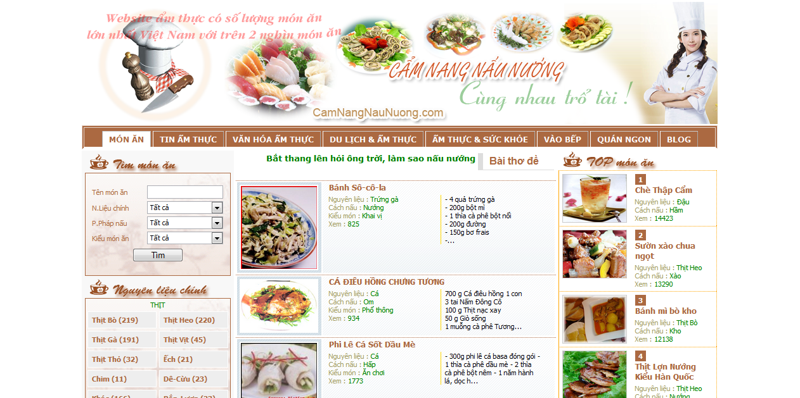

It is a Vietnamese website provides all cooking information not only cooking guides or recipes; it has tips for choosing better materials, cooking better than regular and suggesting some good restaurants. This page has the most recipes in Vietnamese cooking websites with approximate 2000 recipes. All the recipes are posted by the administrator. Users can view but can’t comment because it doesn’t have this function. The search function is very detailed. Users can search by name, main ingredients, cooking manners, or kinds of food. The content of a recipe contains mainly text and just one picture.

1. **Delish (<http://www.delish.com>):**

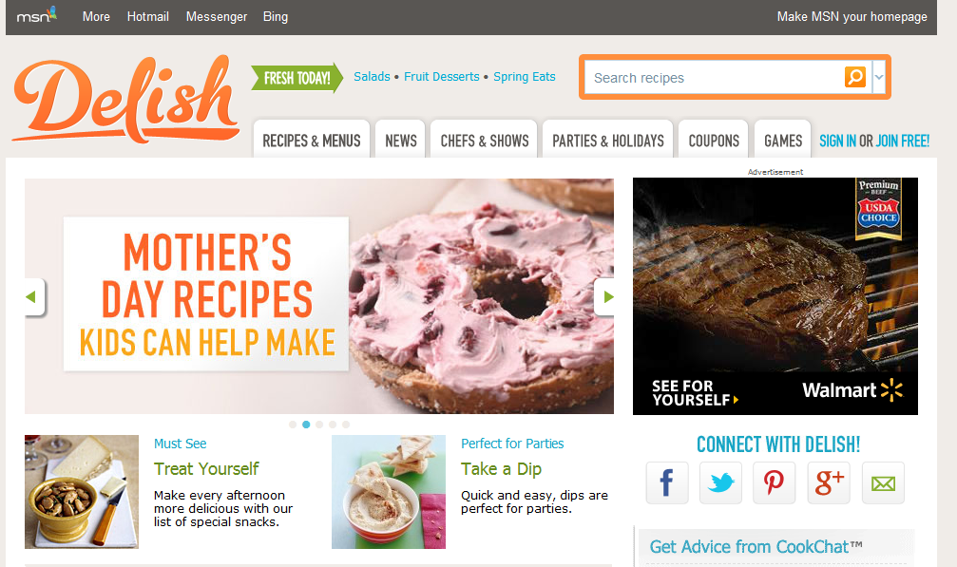

This English website is a part of media social network. It allows readers comment and rate after logging in. Each user has their profile page, and they can ask others about cooking. It also has step-by-step guides and readers can follow the instructions. Most of the recipes are written by professional chefs. The administrator collects them from some websites such as countryliving.com or eatingwell.com… Authorized users can write a recipe or make another version of the existing ones; they also can comment on each recipe but it’s very seldom to see users’ recipes. Even if it has one, the recipe is just “another version” of the main recipe. Although all of the recipes have only one picture, the content of them is quite detailed. Most have nutritional information (per serving). Some have time measurement to complete a dish. The recipes are categorized into kinds of food (cookies, chicken, pasta…), kinds of meals (desserts, lunch, dinner…), time to complete (under 30 minutes), quantities of calories (low calorie) … Recipes are not only viewable, authorized users can also save them to their computers or add them to their accounts to view later without searching again. Moreover, they can share it on their social networks such as twitter, facebook, google+, send emails to friends or print directly through their browsers.

1. **Afamily (<http://afamily.vn/an-ngon>):**

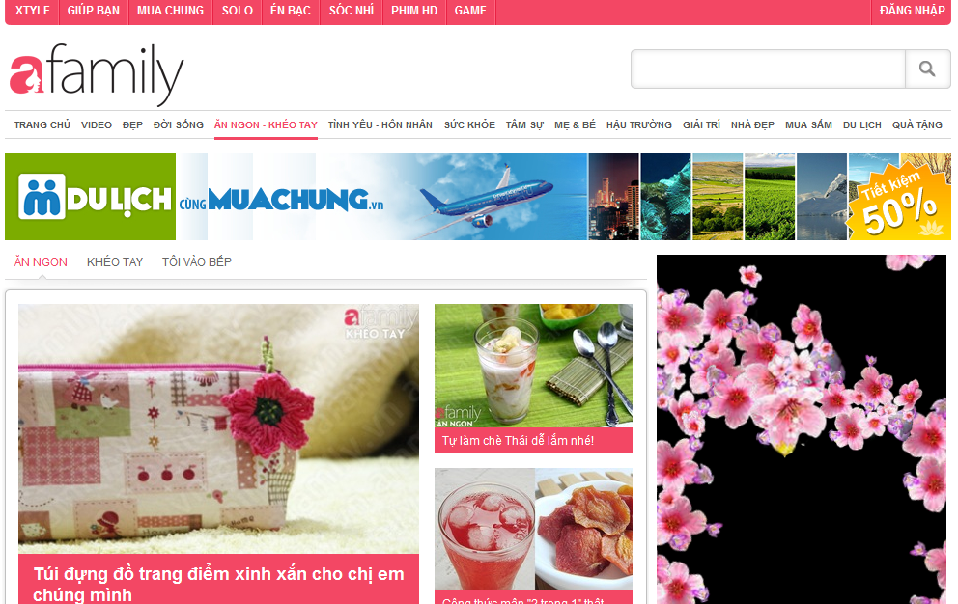

This is a sub-page of Vietnamese website afamily.vn. Its guides are divided into steps for readers to follow. Each step has its own picture. So it is clear and easy for everyone to learn and follow. Pictures of ingredients and dishes are adequate and visual. Maybe recipes are written not only by chefs, but also by users but must pass through the checking process before be posted. Users can comment after logging in. Like delish, users can share it on their social networks and print through their browsers.

1. **Epicurious (http://www.epicurious.com):**

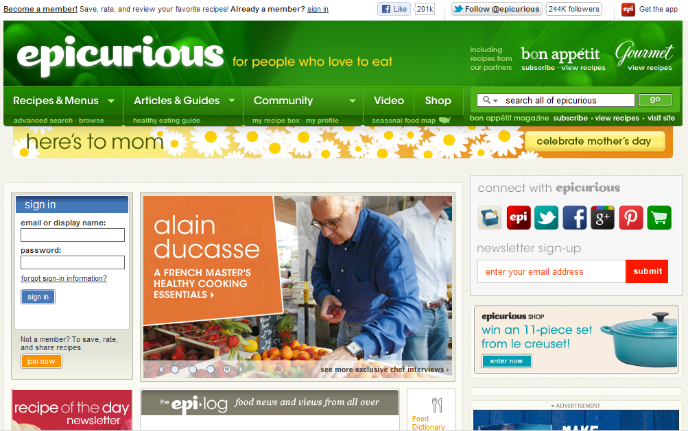

This English website is rated as top 10 cooking guide websites over the world. Its functions are much similar to delish except it has video guides. The point is that it separates member recipes and chef recipes. It also has food dictionary. User can search the same ingredients or tools or dishes but in other names or other languages. It’s much easy to understand if you meet a strange ingredients or dishes…

1. **All Recipes (http://allrecipes.com):**

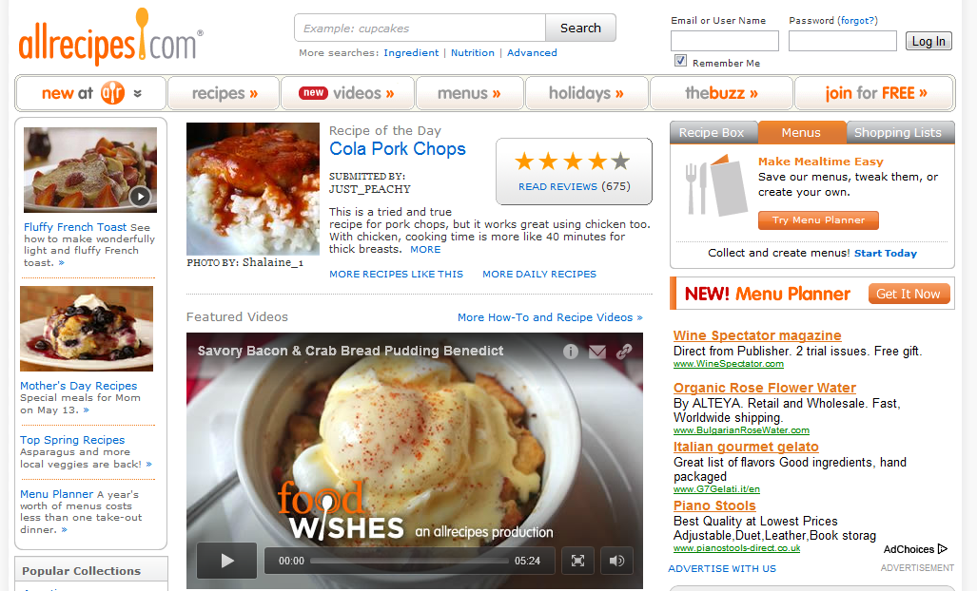

Its functions are similar to other cooking websites (delish, epicurious). But the point of this page is to support other languages, so it is easy for foreigners to understand what the recipes are “saying”. Thus, their job is to focus on how to follow recipes themselves. It also suggests a suitable drink to make a meal more delicious.

# Idea Proposal

### Problem

* Because of the richness and diversity of the Vietnamese dishes, possibly not everyone is aware of the dishes of the other regions, areas, so learning how to cook, how to eat is more and more difficult.
* Busy life makes people accidentally or intentionally forgets the taste of family meals. Many young people now cannot cook or just know how to cook simple dishes. For example, if you want to cook some delicious for your family, lovers… but you do not know what dish to cook or how to cook the dish you want.

Many people in above situations will ask their friends, their relatives, who has experience to know how to cook this, how to cook that… but if they do not know either or if you want to make them surprised, what will you do? You will spend time a lot of time “asking” Google. With huge amount of information, Google will return millions of results. Most of the results are cooking recipes which are written in English. If you can find some recipes in Vietnamese, there are no guarantees that you have enough food ingredients because these recipes are written by professional chefs who are always supplied with adequate ingredients .We are sure that you cannot easily determine what guide is good and suitable for you. You can follow a guide and spend much effort for this but finally fail because you cannot understand one step of this guide or the final dish followed this guide is not suitable for your taste. It is unavoidable.

### Solution

We will build a centralized website where people can go to and share cooking recipes, search for recipes in need, share and learn experience to cook better. They can comment, rate, mark… a recipe to make the information about that is most valuable to others. By providing cooking guides step by step with picture for each, it is easy to understand, remember and follow. We want to save your time, your money, your “happy cooking” moments with delicious dishes are done by yourself to share with your relatives, family, friends… and also help you know more about richness and diversity of Vietnamese dishes.

1. **Advantages**

The idea of ​​creating a specific website that provides cooking recipes and experience is not new. The above websites still exist and develop, but all of them do not have all the features and advantages of website we are building.

By implementing a user-oriented website for Vietnamese users, our product will have the following advantages:

* Specialized for Vietnamese users and Vietnamese dishes.
* Each cooking guide is reviewed, evaluated, rated... by other users, so we will give users the best information they need.
* Utilized newest technologies to make the system user-friendly and have best performance. We provide picture-guides step by step, easy to understand, remember and follow, so you will save time, money…
* With the contribution and opinion from all users, the interaction among users is increased. Our website can be the place that connects people who have common cooking interest.

1. **Disadvantages**

On the other hand, our website also remains some disadvantages.

* As users contribute contents and share their experiences, the contents totally depend on the users, so we must consider the content management carefully.
* Administrator also cannot control the qualities of articles; it depends on registered users by rating, commenting and numbers of view… Each step of cooking guide has a picture and a description, it requires users’ efforts.

The above problems are the direction that we will continue to learn to troubleshoot and develop in the future.

1. **Global picture**

**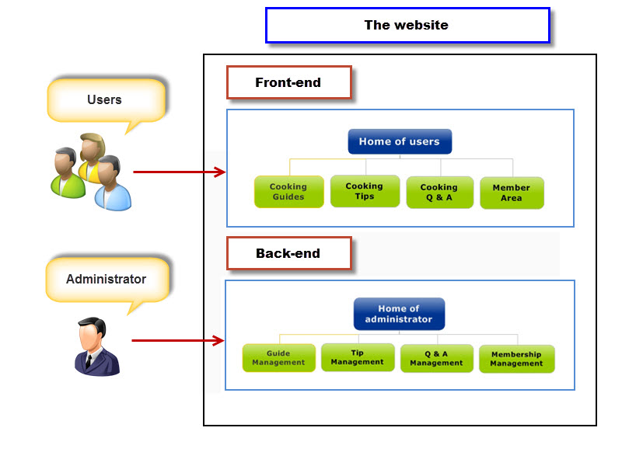**

**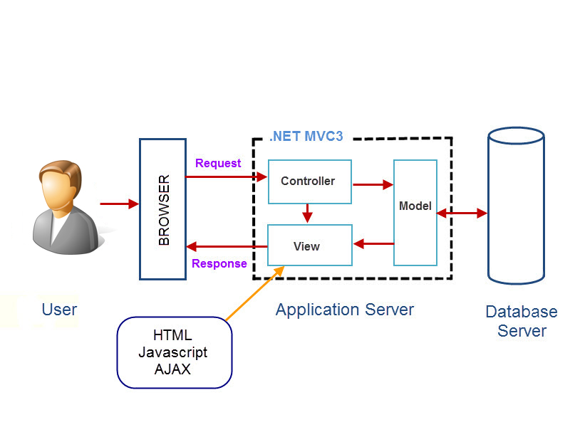**

# References

1. <http://en.wikipedia.org/wiki/Vietnamese_cuisine>